RIHA Mediating Presence

Proposed Presence Demonstrators
(as a result of our “UNFOLD & PREPARE” workshop, Eindhoven 7-8 November 2011)

In conjunction with each workshop in 2012, we will allocate time to collaboratively develop designs and prototyping relating to a shortlist of the following application projects/presence demonstrators. Some are of greater value to partners than others, which will be identified through continued work. At each workshop, there will be an update regarding the development plan of each of the applications projects of interest to RIHA Mediating Presence.

1. Waterphone
Empowering women/Water sensor online/measure quality/Mobile Marketplace/Subscription programme/Design-for-future-trash-programme/
Contact: Lipika Bansal TU Delft

2. Jewellery for inclusion
Independent device, connects to any computer/phone
Contact: Catholijn M Jonker TU Delft (for now)

3. FaceConnector
Overcome cultural boundaries/diminishing prejudice/social bridging/softening social friction/inclusion/understanding/integration tool/social ecosystem
Contact: Karen Lancel TU Delft

4. BeingHere Shared Reflection Tool
Bridging distance in telecom/creating proximity
To be developed within the activity/requires attention (a new brief re functionality)
Semantic web paragraph-levelled (10 units of meaning) content management allows for the creation of new units of meaning. Dialogic-next-generation-publishing-tool collaborative authoring – citation index – conferencing tool.
Contact: Caroline Nevejan TU Delft

5. Demonstrator/Experience lab topic: Mediated sketching table – Augmented teaching Shared negotiation surfaces & shared mediated spaces. Connects to octagonal hang-out
Contact: Charlie Gullström/Leif Handberg KTH

6. Demonstrator: Presence Bubbles – shared awareness/dedicated connection tools
Demos already scheduled/multi touch in process (March 2012)
Participants are interested in what kind of presence tools can be fitted into the bubbles project.
Contact: Kai Kukkaniemi Aalto

7. Shared rythm availability
On-demand-groupware availability and engagement that fits into other commitments. Represents your connection in time to other groups. A functionality that fits the Presence Bubbles, to FaceConnector and to the Mediated Sketching table
Connects also to Philips project Light For You. Connects also to Virtual Tourism,
Near space representation of far space, calibrate body movement
Contact: Catholijn M Jonker TU Delft

8. Demonstrator: Virtual tourism – augmented guide you-in-me app
Synchronize and transmit bodily movement, communicate various sensors
Connect to Shared Rhythm.
Contact Catholijn M Jonker TU Delft

9. Demonstrator: Octagonal hang-out (Power work sessions)
Maximize communication when co-located, using shared tools for co-editing while visualizing everyone’s work simultaneously (activity presence). Can use presence tools to invite ‘experts’ into the work session for consultation (people ready and visualized as bubbles). Everything is shared with everyone in real time, regardless where you are, but with a focus on the people in the room. Come-and-go functionality, in and out of attention, to work collaboratively then split into parallel work and then join/split at need.
Connects to Presence Bubbles (how to represent near space far space), to Mediated Sketching Table, Office 2.0
Contact: Kåre Synnes/Peter Parnes LTU
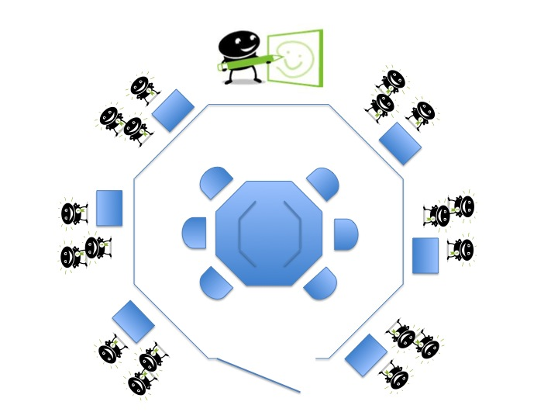

10. Negotiation game for children – augmented teaching
Serious games/smart objects related to online game
Contact: Karen Lancel TU Delft

11. Presence Tangibles - effective contact
e.g. a bluetooth ball that you can control for communication and to trigger contact/unobtrusive/subtle nuance cues
Contact: Peter Parnes LTU

/Charlie Gullström 120110
charlieg@kth.se

