RIHA Mediating Presence Workshop: “UNFOLD & PREPARE”, Eindhoven 7-8 November 2011

Minutes from the final session 110908

Edited by Charlie Gullström, Activity Leader

1. Organization of workshops 2012
We discussed the following issues:
How should workshops be organized? What will be our working methods in 2012? Could we co-locate our workshops with other planned conferences? How can we link to other ICT Labs activity workshops (e.g. Digicities, Smart Spaces)?

An important basis for our interdisciplinary collaboration is that our research questions and perspectives represent a wide spectrum (from hard core science to creative artistic practices) and will thus provide a fruitful tension while we work together. We want to ensure that our workshops are designed to encourage such cross-fertilization, for example in the way of the current workshop. We are all quite happy about the outcome of the workshop which, not least, resulted in as many as 11 proposals for application projects/demonstrators. Workshops must therefore both facilitate theoretical discussions relating to multiple research perspectives AND share prototyping, collaborative design work relating to the development of relevant demonstrators.

We aim towards one End-of-year Conference, based on an open call for papers, which is followed by a book publication. The end of year conference could very well be mediated, yet followed by a co-located workshop. Preparations for a conference in November 2012 will need to start quite soon however, and we will investigate whether our initiative can be linked to others within EIT, in order to minimize work.

The benefit of the BeingHere tool, as we see it, is its potential to generate new links between researchers. It will be fruitful, therefore, to explore its value as part of a conference for which papers have been produced, which on paragraph level relate to certain keywords. BeingHere would generate the links and workshops can be used to discuss these links and what they productively may lead to.

Our primary focus for the moment is therefore to organize 4 internal workshops for ourselves, in order to prepare several interdisciplinary co-authored papers for said conference, using the BeingHere reflective tool. Workshop participants will write short texts beforehand, exploring the metadata keywords of the BeingHere site, allowing the latter to create/generate links between our texts. Each workshop will be arranged according to one of the four topics TIME; RELATION; PLACE; ACTION – allowing researchers to collectively reflect on the potential cross-fertilization of various research perspectives. Designers and relevant contributors will be invited to the workshops.

At each workshop we will also prototype/demonstrate a selection of the various application projects we have already shortlisted (a list of 12 right now).
Each workshop will be organized over 2-3 days allowing sufficient time to discuss cross-fertilization of theoretical texts as well as collaborative prototyping.

2. Time Schedule 2012

The group decided on the following workshop dates and allocation of responsibilities. Need for changes due to clashes etc should be communicated to the Activity Leader within a few weeks time.

TU Delft/Eindhoven - January 25-27 - TIME Caroline Nevejan/Kai Kukkaniemi
LTU Luleå - March 14-15-16 - RELATION Kåre Synnes/Peter Parnes
KTH Stockholm -June 18-19-20 - PLACE - Charlie Gullström/Leif Handberg
TU Delft/Eindhoven -September 18-19-20 - ACTION - Martijn Warnier

+ A Mediated Presence Conference -November 21-23 (preliminary date)

3. General preparations for 2012
Based on the results of the workshop, Caroline and Charlie will now discuss how to prepare each workshop together with those who have taken responsibility. A proposal will be sent around in a few weeks.
The detailed contributions 2012 from all participants will be planned following the tasks already expressed in the budget. A go-ahead from EIT ICT Labs is expected early December.

Each workshop will address a primary research question relating to the theme. It will focus theoretical work and cutting edge research (presence design) which has relevance to concerns on how our networked society populates the planet-

In conjunction with each workshop, we will allocate time to collaboratively develop designs and prototyping relating to a shortlist of the various application projects/demonstrators we have already initiated (see below). Some of these are of greater interest to partners than others, which will be identified through continued work.

At each workshop, there will be an update regarding the development plan of each of the applications projects of interest to RIHA Mediating Presence.

As part of workshop preparations for 2012, we will also schedule which applications that are most suitable for demonstration/prototyping at which workshop.

Charlie and Caroline will further prepare a documentation of various existing studies, in order to establish common grounds within the RIHA Mediating Presence Activity: A collection of our starting Body of Knowledge.

4. Application projects/demostrators and designs that were proposed at the workshop

Below a very brief summary+ primary contact person(s). The contact person should be cc:d in every exchange, as these proposals will henceforth be elaborated via email, google docs and separate meetings. A regular report on the developments is requested, sent to the activity leader every month. All interested partners will however be welcomed to join throughout 2012.

1. Waterphone
Empowering women/Water sensor online/measure quality/Mobile Marketplace/Subscription programme/Design-for-future-trash-programme/
Contact: Lipika Bansal TU Delft

2. Jewellery for inclusion
Independent device, connects to any computer/phone
Contact: Catholijn M Jonker TU Delft (for now)

3. FaceConnector
Overcome cultural boundaries/diminishing prejudice/social bridging/softening social friction/inclusion/understanding/integration tool/social ecosystem
Contact: Karen Lancel TU Delft

4. BeingHere Shared Reflection Tool
Bridging distance in telecom/creating proximity
To be developed within the activity/requires attention (a new brief re functionality)
Semantic web paragraph-levelled (10 units of meaning) content management allows for the creation of new units of meaning. Dialogic-next-generation-publishing-tool collaborative authoring – citation index – conferencing tool.
Contact: Caroline Nevejan TU Delft

5. Demonstrator/Experience lab topic: Mediated sketching table – Augmented teaching Shared negotiation surfaces & shared mediated spaces. Connects to octagonal hang-out
Contact: Charlie Gullström/Leif Handberg KTH

6. Demonstrator: Presence Bubbles – shared awareness/dedicated connection tools
Demos already scheduled/multi touch in process (March 2012)
Participants are interested in what kind of presence tools can be fitted into the bubbles project.
Contact: Kai Kukkaniemi Aalto

7. Shared rythm availability
On-demand-groupware availability and engagement that fits into other commitments. Represents your connection in time to other groups. A functionality that fits the Presence Bubbles, to FaceConnector and to the Mediated Sketching table
Connects also to Philips project Light For You. Connects also to Virtual Tourism,
Near space representation of far space, calibrate body movement
Contact: Catholijn M Jonker TU Delft

8. Demonstrator: Virtual tourism – augmented guide you-in-me app
Synchronize and transmit bodily movement, communicate various sensors
Connect to Shared Rhythm.
Contact Catholijn M Jonker TU Delft

9. Demonstrator: Octagonal hang-out (Power work sessions)
Maximize communication when co-located, using shared tools for co-editing while visualizing everyone’s work simultaneously (activity presence). Can use presence tools to invite ‘experts’ into the work session for consultation (people ready and visualized as bubbles). Everything is shared with everyone in real time, regardless where you are, but with a focus on the people in the room. Come-and-go functionality, in and out of attention, to work collaboratively then split into parallel work and then join/split at need.
Connects to Presence Bubbles (how to represent near space far space), to Mediated Sketching Table, Office 2.0
Contact: Kåre Synnes/Peter Parnes LTU
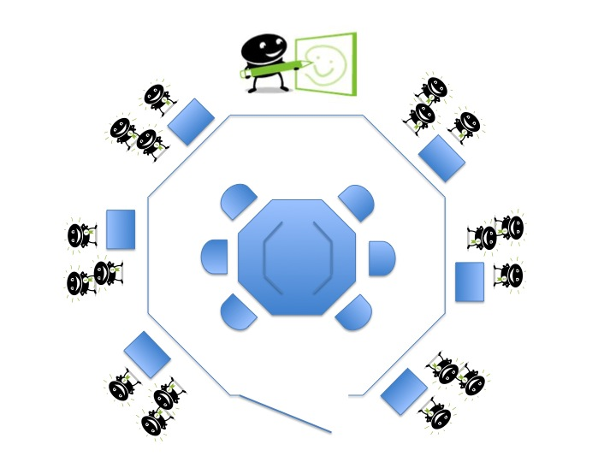

10. Negotiation game for children – augmented teaching
Serious games/smart objects related to online game
Contact: Karen Lancel TU Delft

11. Presence Tangibles - effective contact
e.g. a bluetooth ball that you can control for communication and to trigger contact/unobtrusive/subtle nuance cues
Contact: Peter Parnes LTU

